# Abstract

The Sydney Airbnb Data software is user friendly in the most sense. It is a robust IT solution designed to offer users a comprehensive understanding of the Sydney rental market. It would give users the ability to efficiently browse property data thanks to its user-centric design. It offers a comprehensive perspective of the rental landscape with tools including Suburb Listing, Price Charts, Keyword Search, Cleanliness Analysis, and Home Type Analysis. The program is a web-based platform made to give users useful information and practical tools for researching the Sydney Airbnb market. The application's clean and user-friendly interface enhances usability, making it an straightforward resource for those interested in Sydney's Airbnb offerings.

# Introduction

An executive summary of the study conducted for the Sydney Airbnb Data study and Visualization web application is provided in this report. The summary evaluates the 5 functionalities of the web application, as described in the project requirements, over a 12-month time frame. The respective functionalities are as follows; Search by Suburb Listing, Price Charts, Keyword, Comments and Property Types. Each function had its own unique dates given for a more diverse data search, which will be discussed, however the timeframes are all well within in the bounds of 12 months. The web application provides an easy to use interface that is simple to interpret.

Main Page of Application

# **Analysis 1 Suburb Listing**

Based on their precise needs for area and time frame, customers can effectively filter down Airbnb housing possibilities in Sydney using the "Suburb Listing” tool, according to an analysis of the feature. Users who enter these criteria are presented with an organized list of lodging options in the selected suburb for the given time frame. By streamlining the search process and accelerating the time it takes to identify relevant results, this functionality significantly improves the user experience. Users simply input their desired timeframe and select the Suburb, via a dropdown menu presenting a range of suburbs, within Syndey. Once the function is executed a listing of available Suburbs within that time frame is provided by the application. Below are examples of the functionality, note the timeframes set are different but within 12 months.

**1.1. User Setting Time Frame and has selected Suburb, which in this case is Mosman.**

**Dropdown menu of Suburbs within Sydney**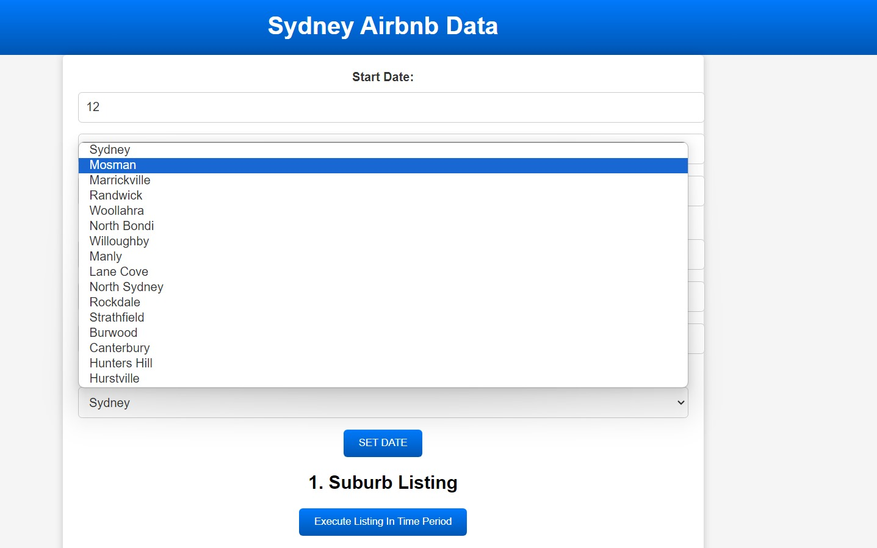

**1.2. Once the function is executed, A listing of available Airbnb’s are provided according to the users desired timeframe and suburb.**

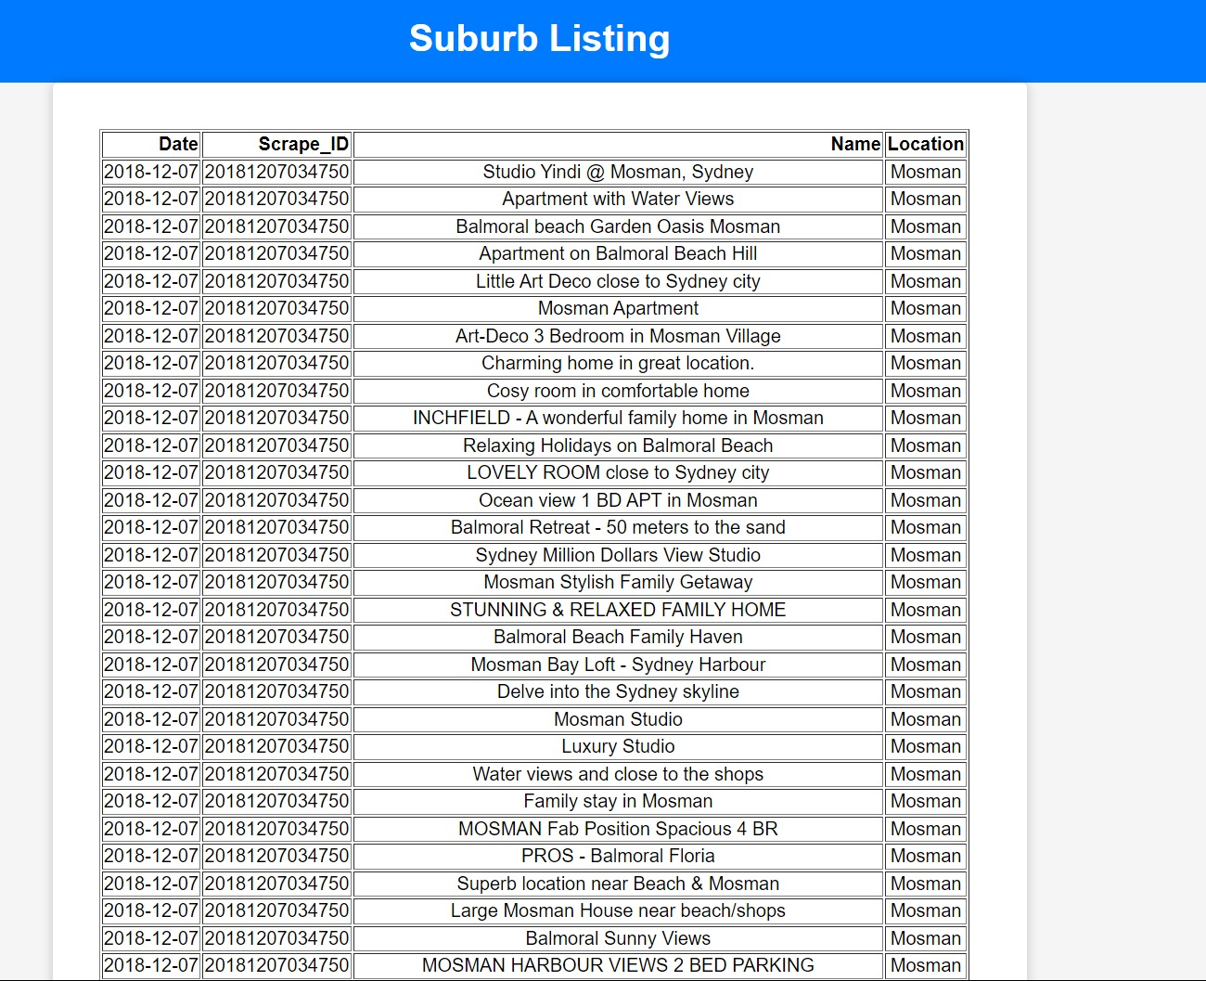

**2.1. User Setting Time Frame and has selected Suburb, which in this case is North Bondi.**

**2.2. Once the function is executed, A listing of available Airbnb’s are provided according to the users desired timeframe and suburb.**

# **Analysis 2 Price Charts**

Users can gain useful insights into price trends in the Sydney Airbnb rental industry by using the "Price Charts" function. The software creates a chart that shows how rental costs frequent rental costs are through different ranges. The functionality is quite simple here as after a selected timeframe is set all the user has to do is click the Price Charts button to retrieve a chart presenting the price distributions.

* 1. **User has set timeframe for the whole year of 2019**  
     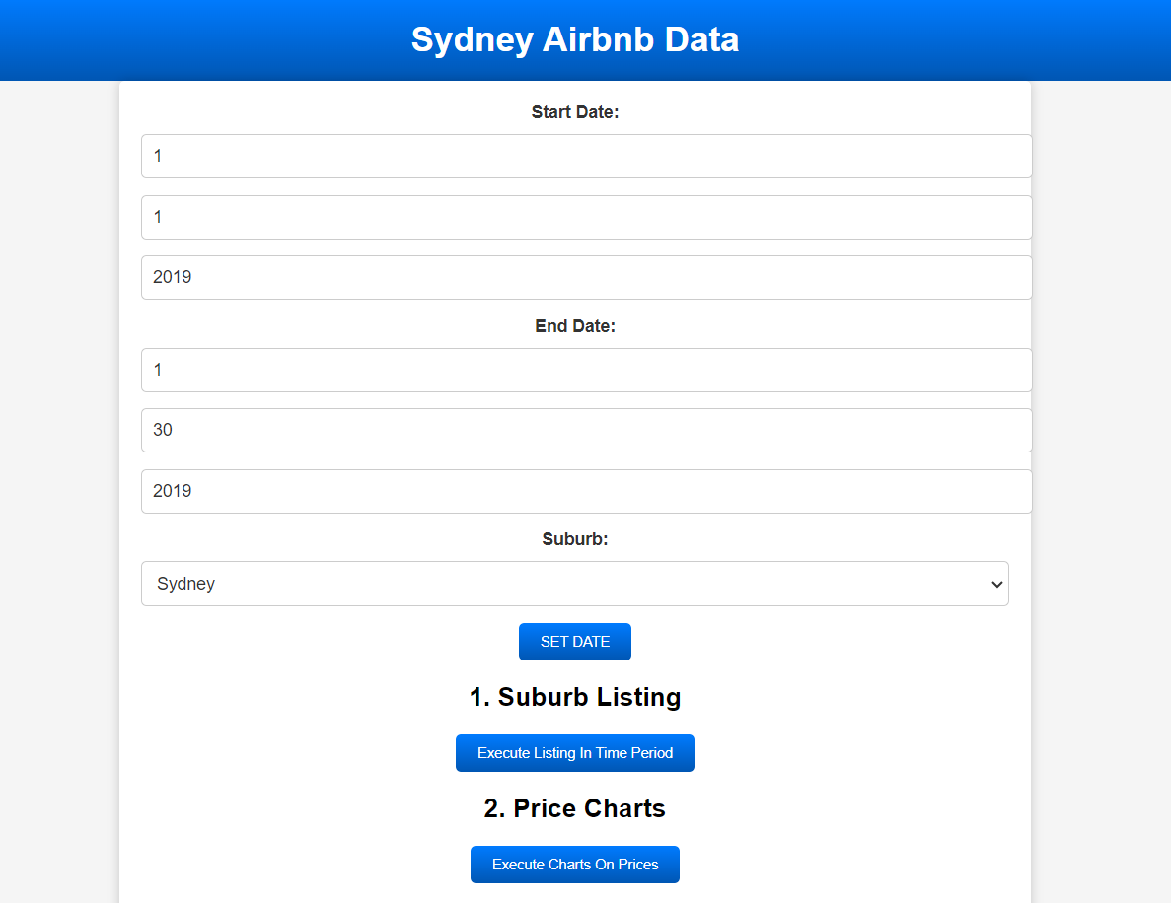

**1.2. Price Distribution is provided for Sydney Airbnb’s and their frequencies**  
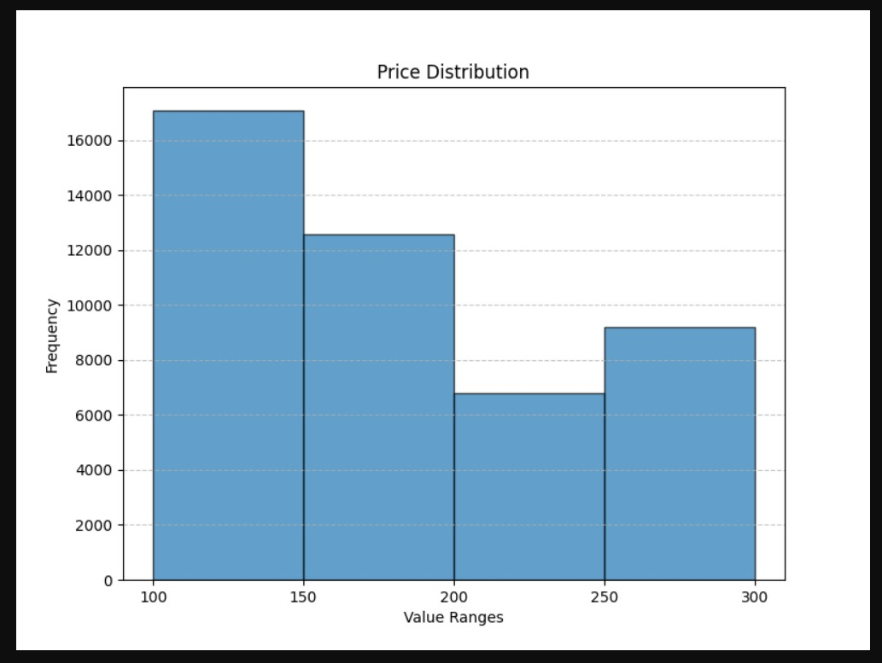

**2.1. User has set timeframe for December 2017 to December 2018**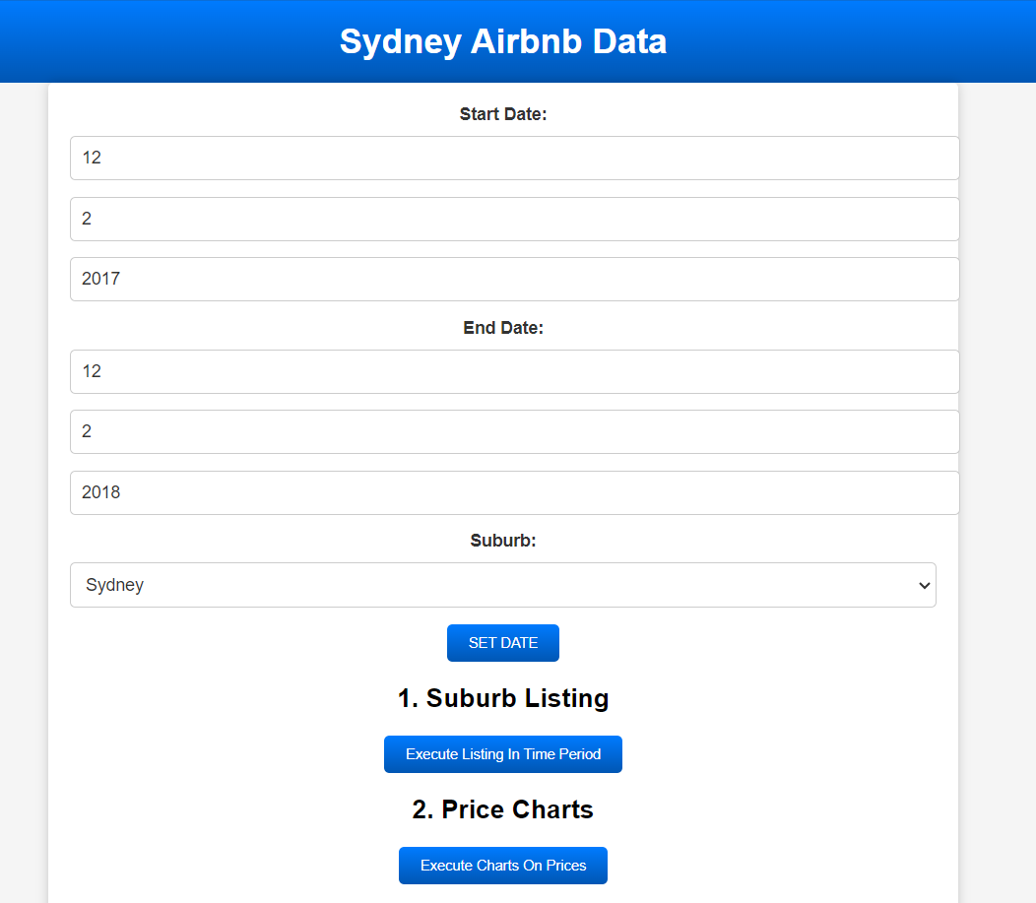

**2.2. Price Distribution is provided for Sydney Airbnb’s and their frequencies.**

# **Analysis 3 Keyword Search**

Users can use particular terms relating to their preferences to search for Airbnb listings utilizing the "Keyword Search" function. The search procedure is made simpler by the system retrieving entries that contain the requested keywords. Users can effectively narrow down homes based on features and circumstances, improving their chances of finding lodging that meets their needs. Users simply open the Keyword Search page via the “Execute Keyword in Reviews” button. The function is easy to use and understand. By simply searching for keywords, users are provided with respective reviews that speak of and relate to the keywords, furthermore, are provided with the quantity of reviews with the searched keyword. Below are some examples of user engagements with this function.

**Note:** These results are set from the middle of the year 1027 to the middle of the year 2018.

**1. Here the user has searched for the keyword ‘pool’ and is presented with related reviews.  
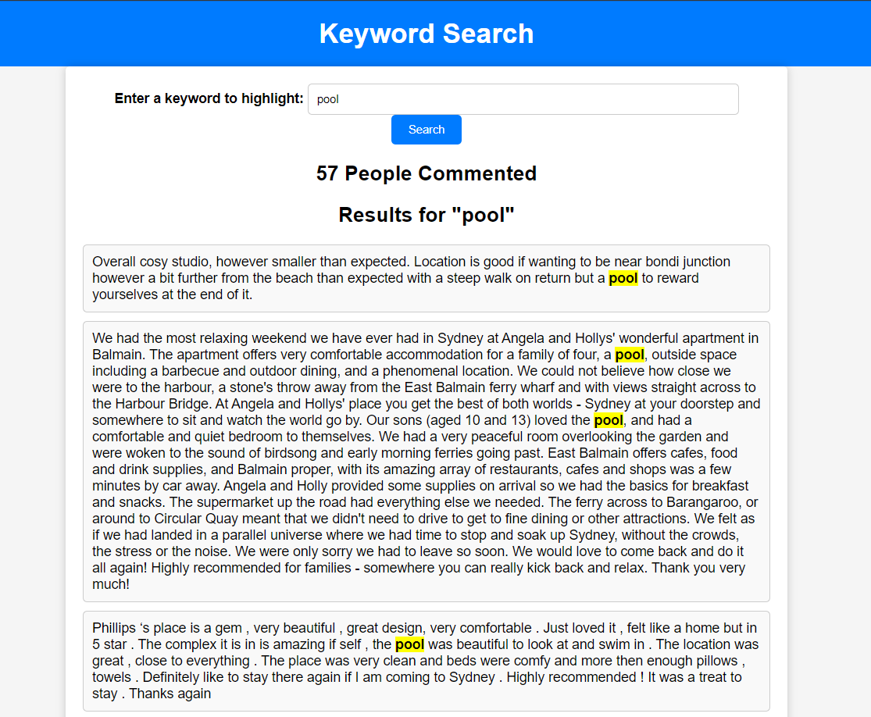**

**2. Here the user has searched for the keyword ‘dogs’ and is presented with related reviews.**

**3. Here the User has searched the phrase ‘two bedroom’. To note as well, not only keywords can be searched but also phrases.**  
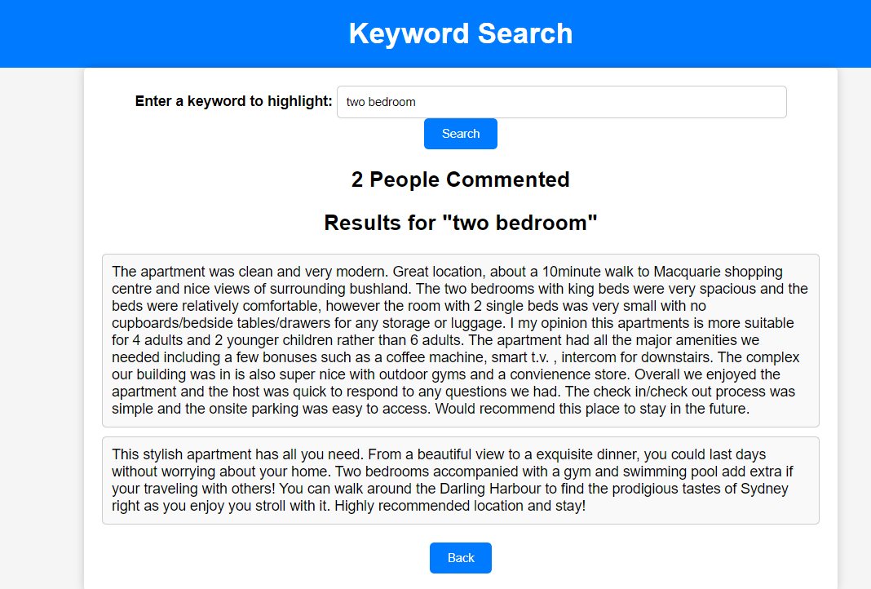

# **Analysis 4 Cleanliness Analysis**

With the cleanliness function, users can review a pre-set listing of keywords that relate to cleanliness. Keywords such as clean, spotless, and neat all extracted from the review’s dataset. The keywords are then quantified based on how many times they appear in the reviews and are presented. The listings are given based on what timeframe or dates the reviews were given; this allows users to retrieve data based on specific dates. Below are some examples.

* 1. **Here the timeframe of all of 2017 has been set.**

* 1. **Once the function is engaged, a listing of the count of times the keywords relating to cleanliness is presented.**  
     A screenshot of a computer

     Description automatically generated

**2.1 Here the dates are set for all of 2018**

**2.2 A listing of the number of times keywords relating to cleanliness was referred to in reviews for all of 2018 is presented.**

# **Analysis 5 Home Type Analysis**

This analysis function reviews all the different Airbnb housing types and provides a chart of the percentage of them within Sydney. The current dataset reviewed is from all of Sydney and is quite constant.

Once the Home Type Analysis function is engaged, the application analyses the housing types and presents the chart. The function is quite simple and easy to understand. The graphing of the data is very appropriate to use to scout Airbnb and would a useful tool for housing agents.

**Chart of 3 Housing types of Airbnb in Sydney.**